Bootstrap

Задание - Сверстать админ панель по образцу, используя технологию bootstrap

https://www.figma.com/file/mkPlxbCLholAV4MzD6rY9r/Dashboard-(Copy)?node-id=1%3A3

рекомендации

- руководство htt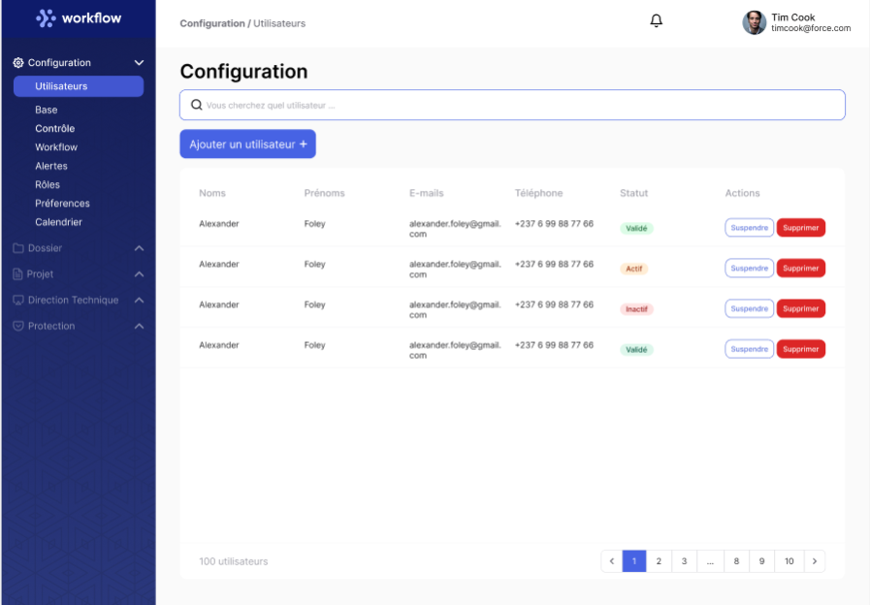ps://bootstrap-4.ru/docs/4.6/getting-started/introduction/
- справочник https://html5css.ru/bootstrap4/default.php
- для подключения шрифтов fontawesome:

<link href="https://maxcdn.bootstrapcdn.com/font-awesome/4.2.0/css/font-awesome.min.css" rel="stylesheet">
<script src="https://kit.fontawesome.com/7c5b070f49.js"></script>

для использовыания шрифта font-family: 'Font Awesome 5 Free';

- для подключения selector ttps://developer.snapappointments.com/bootstrap-select/

<!-- Latest compiled and minified CSS -->
<link rel="stylesheet" href="https://cdn.jsdelivr.net/npm/bootstrap-select@1.13.14/dist/css/bootstrap-select.min.css">

<!-- Latest compiled and minified JavaScript -->
<script src="https://cdn.jsdelivr.net/npm/bootstrap-select@1.13.14/dist/js/bootstrap-select.min.js"></script>

<!-- (Optional) Latest compiled and minified JavaScript translation files -->
<script src="https://cdn.jsdelivr.net/npm/bootstrap-select@1.13.14/dist/js/i18n/defaults-*.min.js"></script>

и нужно подключение
<script src="https://cdnjs.cloudflare.com/ajax/libs/popper.js/1.14.3/umd/popper.min.js" integrity="sha384-ZMP7rVo3mIykV+2+9J3UJ46jBk0WLaUAdn689aCwoqbBJiSnjAK/l8WvCWPIPm49" crossorigin="anonymous"></script>

